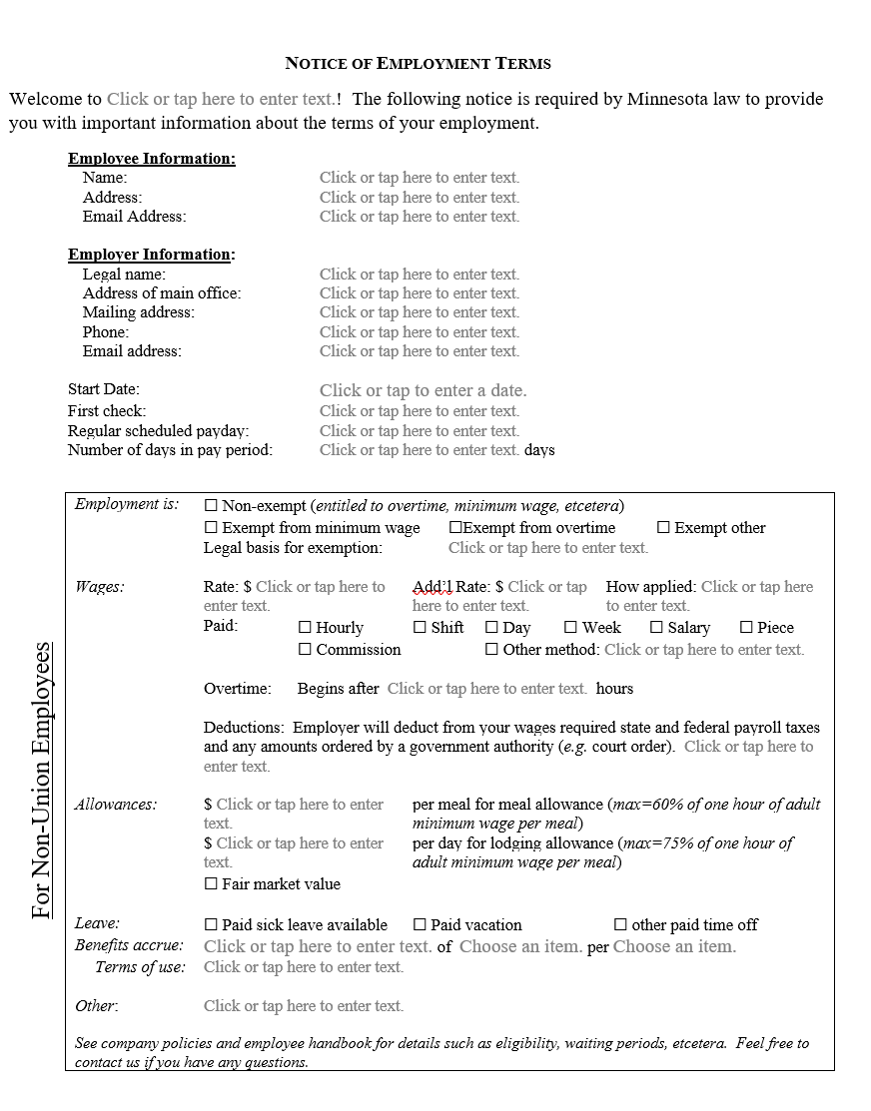

Required by Minn Stat § 181

Name of your business

Day of the week, then # of days in payperiod (commonly 7)

Start of employment or re-employment

Full legal name

Only required if employer is crediting the allowance toward a wage (Mn Rule 5200.0060 & 00700).

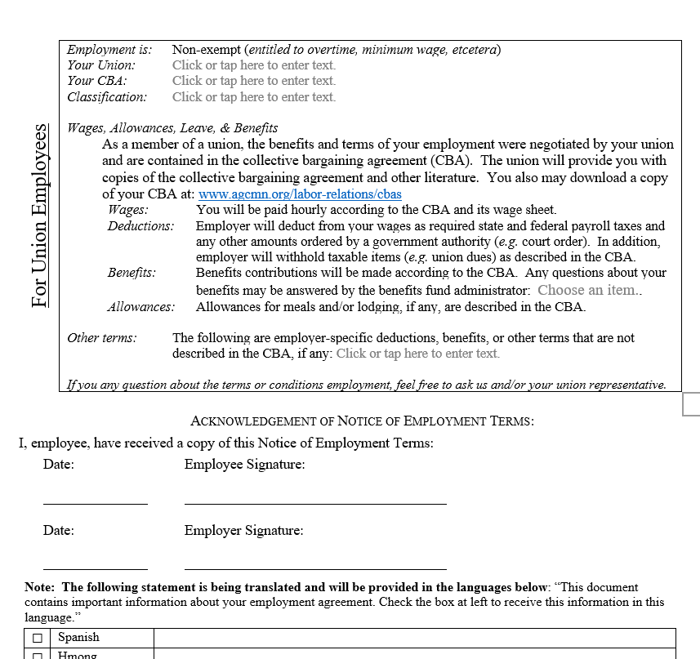

Eg. PTO given, wages above scale, etc.

2 copies—one for your files & one to give employee

DLI is translating this and we will update the form

AGC-Mn has posted the CBAs to provide this link

Eg, foreperson, journeyperson, apprentice, pre-apprentice; and, if applicable, percent vested

Name & local number of union that employee is a member

Which CBA covers the employee (include Highway or building, & area if applicable)