# COVID-19 Preparedness Plan template and instructions

Executive Order 20-40, issued by Governor Tim Walz on April 23, 2020, requires each business in operation during the peacetime emergency to establish a “COVID-19 Preparedness Plan.”

A business’ COVID-19 Preparedness Plan shall establish and explain the necessary policies, practices and conditions to meet the Centers for Disease Control and Prevention (CDC) and Minnesota Department of Health (MDH) guidelines for COVID-19 and federal Occupational Safety and Health Administration (OSHA) standards related to worker exposure to COVID-19. The plan should have the strong commitment of management and be developed and implemented with the participation of workers. The Minnesota Department of Labor and Industry, in consultation with MDH, has the authority to determine whether a plan is adequate.

Your COVID-19 Preparedness Plan must include and describe how your business will implement at a minimum the following:

1. infection prevention measures;
2. prompt identification and isolation of sick persons;
3. engineering and administrative controls for social distancing;
4. housekeeping, including cleaning, disinfecting and decontamination;
5. communications and training for managers and workers necessary to implement the plan; and
6. provision of management and supervision necessary to ensure effective ongoing implementation of the plan.

This document includes a sample COVID-19 Preparedness Plan that meets the criteria listed above. No business is required to use this model. If you choose to use this model, you must adapt it to fit the specific needs of your business.

# COVID-19 Preparedness Business Plan for Associated General Contractors of Minnesota

***Special Notice****: Associated General Contractors of Minnesota’s office is temporarily closed to outside   
guests & members / visitors. We welcome all phone calls and email/virtual meeting requests.*

**Associated General Contractors of Minnesota (AGC)** is committed to providing a safe and healthy workplace for all our staff and members. To ensure that, we have developed the following Preparedness Plan in response to the COVID-19 pandemic. AGC staff at all levels are all responsible for implementing this plan. Our goal is to mitigate the potential for transmission of COVID-19 in our workplace, and that requires full cooperation among workers and management. Only through this cooperative effort can we establish and maintain the safety and health of our workers and workplace.

AGC staff is responsible for implementing and complying with all aspects of this Preparedness Plan. All AGC staff members have the full support of management and the AGC Board of Directors in enforcing the provisions of this policy.

Our staff and members are our most important assets. We are serious about safety and health, and keeping our dedicated employees and association members safe at AGC. Employee involvement is essential in developing and implementing a successful COVID-19 Preparedness Plan. We have involved our employees at Associated General Contractors of Minnesota in this process by designating Doug Swenson (Director of Safety & Field Training, p: 651-796-2192, c: 612- 910-1737, [dswenson@agcmn.org](mailto:dswenson@agcmn.org)) as the person to address any and all concerns from staff or membership regarding the safe operation of the AGC office (525 Park Street, Suite 110, St. Paul, MN 55103). We also welcome any staff suggestions/comments regarding maintaining personal safety while at work or home. Our Preparedness Plan follows Centers for Disease Control and Prevention (CDC) and Minnesota Department of Health (MDH) guidelines and federal OSHA standards related to COVID-19 and addresses:

* hygiene and respiratory etiquette;
* engineering and administrative controls for social distancing;
* housekeeping – cleaning, disinfecting and decontamination;
* prompt identification and isolation of sick persons;
* communications and training that will be provided to managers and workers; and
* management and supervision necessary to ensure effective implementation of the plan.

|  |  |
| --- | --- |
|  | Screening and policies for employees exhibiting signs and symptoms of COVID-19 |

All staff members have been informed of and encouraged to self-monitor for signs and symptoms of COVID-19. The following policies and procedures are being implemented to assess workers’ health status prior to entering our office, and for employees to report when they are sick or experiencing symptoms. AGC offers the option of working from home to all staff who can perform their duties remotely. For staff requesting to report to the AGC office for work, there will be a daily questionnaire form (Attachment A) required to be competed as well as a daily temperature scan.

Health screening will be self- administered using the (Braun) ThermoScan thermometer

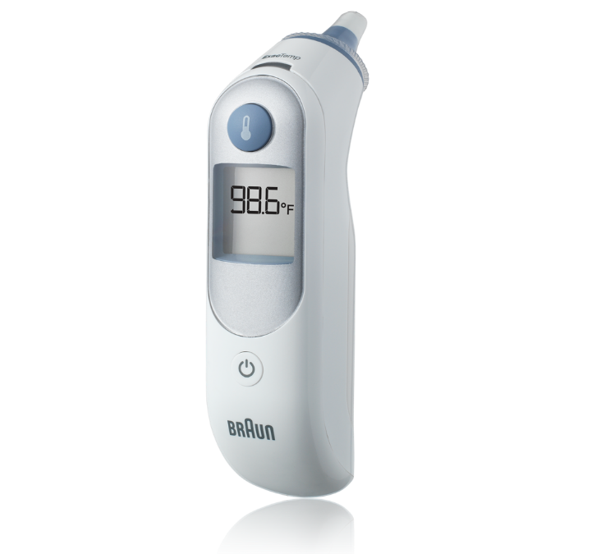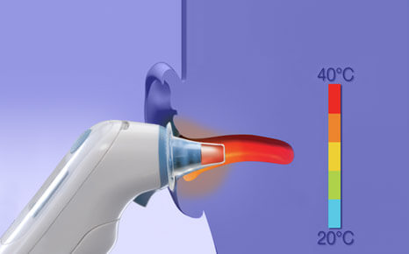

Employee training on the (Braun) ThermoScan thermometer will follow the instructions at this link:

<https://www.youtube.com/watch?v=nqXtzF7guVk&list=PL_qaplcfgDaJVRCndT0IxbFwOMycy65Np>

Employees will be asked the following questions:

* Do you currently or have you in the past 14 days experienced fever (100.4°F or higher) without using fever reducing medication?
* If your temperature is >/=100.4 F, do not stay at your office. Contact your medical provider for direction.
* Please understand that this is not a test for the virus – however, it does give a good indication if someone is potentially unwell.

**Employees Personal Responsibilities**

* Employees need to take steps to protect themselves. Refer to CDC guideline: How to Protect Yourself. <https://www.cdc.gov/coronavirus/2019-ncov/prepare/prevention.html>
* It is critical that individuals NOT report to work or stay at work if they are experiencing symptoms of acute respiratory illness (i.e., **fever, cough, shortness of breath, sore throat, runny/stuffy nose, body aches, chills, or fatigue**), Individuals should seek medical attention if they develop these symptoms. They must stay home and not come to work until free of symptoms for at least 72 hours, without the use of medicine, or as recommended by the CDC. Refer to CDC guideline: What To Do if You Are Sick. <https://www.cdc.gov/coronavirus/2019-ncov/if-you-are-sick/steps-when-sick.html>
* [Guidance in the event someone in an employee’s house gets sick](https://www.cdc.gov/coronavirus/2019-ncov/community/home/index.html):   
  <https://www.cdc.gov/coronavirus/2019-ncov/hcp/guidance-prevent-spread.html#precautions>
* Employees must notify their supervisors and stay home if they are sick. They must seek medical attention if they develop symptoms of acute respiratory illness.
* Employees are discouraged from using other workers’ phones, iPads, electronic devices, desks, workstations, offices, tools, and equipment, including (PPE) personal protective equipment.

**Employee Health Screening**

In addition to limiting outside visitors from all work locations, persons returning to office location and participants in essential meetings must be screened before being allowed at any work location. The screening will follow CDC recommendations and ask the following questions:

1. Have you been diagnosed with COVID-19?

2. Are you currently or have you in the past 14 days experienced fever (100.4°F or higher) without using fever reducing medication, coughing or shortness of breath?

3. Have you traveled internationally, been on a cruise, or been to any domestic location categorized as Level 3/high risk by the CDC in the last 14 days?

4. In the last 14 days, have you been in close contact* (see below for definition) with anyone who has been diagnosed with COVID-19?

5. In the last 14 days, have you been in close contact* (see below for definition) with anyone who:

a. is experiencing symptoms and may have COVID-19 but is yet to be confirmed as a positive, OR

b. has been exposed to someone with a confirmed case of COVID-19?

*CLOSE CONTACT is defined as:

* Being within approximately 6 feet (2 meters) of a COVID-19 case or potential case for a prolonged period of time; close contact can occur while caring for, living with, working with, visiting, or sharing a healthcare waiting area or room with a COVID-19 case or potential case OR
* Having direct contact with infectious secretions of a COVID-19 case or potential case (e.g. being coughed on)   
    
  If the employee answers yes to any of the questions above, their access to the office is prohibited until a the COVID-19 Supervisor responds and contacts them to discuss their return to the work location. If the supervisor determines the person must quarantine for a period of time, the employee will again need to complete the screening questionnaire prior to returning to a work location.

|  |  |
| --- | --- |
|  | Disease Transmission |

COVID-19 is transmissible by respiratory secretions such as saliva or mucus. Infected individuals can spread it by introducing the virus into the air, which can then be inhaled by other individuals nearby. Though unproven, there is also concern that COVID-19 may be transmitted by touching a surface or object that has the virus on it and then touching your mouth, nose or eyes. For these reasons, people are advised to cover their cough, wash their hands, and disinfect frequently touched surfaces to prevent transmission of the disease.

**Cover your mouth and nose with a cloth face cover when around others**

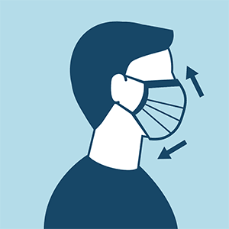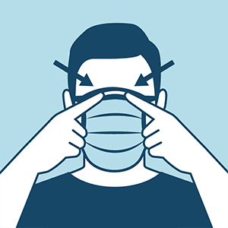

* You could spread COVID-19 to others even if you do not feel sick.
* Everyone should wear a [cloth face cover](https://www.cdc.gov/coronavirus/2019-ncov/prevent-getting-sick/diy-cloth-face-coverings.html) when they have to go out in public; for example, to public hallways, public lobbies, grocery stores, or to pick up other necessities.
  + Cloth face coverings should not be placed on young children under age 2, anyone who has trouble breathing, or is unconscious, incapacitated, or otherwise unable to remove the mask without assistance.
* A cloth face cover is meant to protect other people in case you are infected.
* Do NOT use a face mask meant for a healthcare worker.
* Continue to keep about 6 feet between yourself and others. A cloth face cover is not a substitute for social distancing.

|  |  |
| --- | --- |
|  | Social Distancing |

Social distancing is a new concept to most of us. To prevent transmission of the virus through the air through saliva or mucus, the CDC recommends maintaining a distance of 6 feet from another person. By maintaining a proper “social distance” of 6 feet from others, we will prevent transfer of the virus when someone coughs, sneezes or speaks.

AGC of Minnesota is implementing the following recommended practices for our office staff:

* Change work shifts/start times or stagger start times to allow for 15-to-30-minute buffers between employees if possible so that employees don’t make contact during movement / transition.
* When exercising social distancing, AGC staff should use the line at the their office door threshold where the hallway carpet meets their office carpet as the boundary of the 6’ stop line from the door to co-worker desk as the safest location without entering their coworkers’ individual office space.
* Limit physical contact with other employees to increase personal space (of at least 6 feet, whenever possible).
* Whenever possible, employees in the kitchen/copier room should be limited to two persons who are 6 feet apart at all times.
* Do not stand next to door openings or in hallways.

* **In the event of an emergency, have an Emergency Action Plan** with rally points for 10 people or less outside & inside including severe/tornado weather shelters. The **AGC severe weather (safe) place** is located in the first-floor stairwell (westside) across from the main lobby elevators. If possible, staff should bring their cloth facemasks with them, as it may be difficult to exercise recommended 6’ social distancing while in the severe weather location.
* When possible, limit in-person meetings and replace them with phone or online meetings.
* **Take breaks** and lunch in shifts to reduce the size of the group in the lunch area at any one time to less than 4-10 people, depending on the size of the location.
* Reconfigure break spaces to allow social distancing of at least 6 feet between employees.
* Clean and disinfect break tables at the end of each break.
* Do not congregate in lunch/break areas outside of designated lunch/break times.



**Conduct phone/e-mail /virtual meetings instead of in-person meeting even when at office where possible.**

If held on site, the following will apply for all meetings:

* Only half the indicated capacity of the meeting room is permitted. (e.g. if normal capacity is 10 chairs – only 5 persons allowed). No more than 10 people in any room
* There must be at least one seat between every person
* If possible, open windows
* Meetings should be kept as short as possible
* General hygiene practices to be adhered to
* Discourage hand-shaking and other contact greetings.
* When in-person meetings are required, maintain social distancing.
* Eliminate community accessible food (such as lunch buffets, donuts, candy dishes, etc.).
* Eliminate community coffee pots, water dispensers, hot boxes and microwaves from break and other common areas.
* Provide touch-free solutions
* Water should only be provided in individual-serving containers.

**Leave Policy**

AGCrecognizes that employees may need to work from home or take time off from work because of COVID-19. Our Leaves of Absence policies in the Employee Handbook describe our leave policies. The important piece is to request approval from AGC’s CEO and stay in good communication with office staff, as you are able. There may be sick time benefits under the law and through insurance, and some of these benefits may change so it will be best to ask at the time of your leave. You also may have PTO time available.

AGChas also implemented a policy for informing staff if they have been exposed to a person with COVID-19 at their workplace and requiring them to quarantine for the required amount of time. AGC CEO Tim Worke will communicate to all affected staff if a suspected exposure has occurred.

In addition, this policy has been implemented to protect the privacy of workers’ health status and health information. All AGC COVID-19 Virus report to work daily employee screening forms will be kept confidential in their individual private office and will be the direct responsibility of the self-reporting employee.

|  |  |
| --- | --- |
|  | Housekeeping & Facilities Sanitization |

Regular housekeeping practices are being implemented, including routine cleaning and disinfecting of work surfaces, office equipment in areas in the work environment, including restrooms, break rooms, lunch rooms and meeting rooms. Frequent cleaning and disinfecting will be conducted in high-touch areas, such as phones, keyboards, touch screens, controls, door handles, elevator panels, railings, copy machines, etc. Thorough cleaning of ALL shared surfaces throughout the facility at least once every 24 hours.

AGC staff housekeeping responsibility may include:

- Cleaning and sanitizing surfaces frequently.

- Regularly sanitizing restroom key holders

- Cleaning conference/meeting rooms after every meeting.

- Wiping the kitchen area and copier /workroom at least every 24 hours, in most cases at the beginning of each day.

- Making wipes, sanitizer and cleaning products widely accessible throughout workplaces.

- Cleaning the break rooms and common touch areas (doorknobs, refrigerator handles, etc.) every 24 hours of use.

|  |  |
| --- | --- |
|  | Hand Washing, Personal Protection and Facilities Cleaning & Sanitizing |

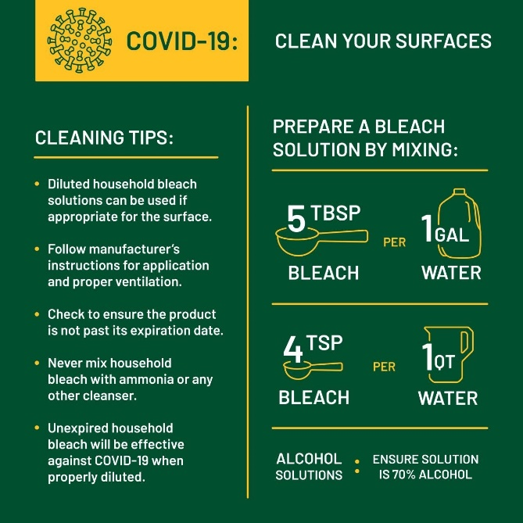 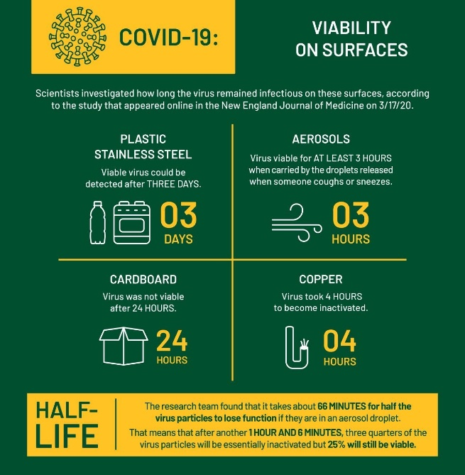

AGC will provide cleaning products and instruct employees how to clean their hands often with an alcohol-based hand sanitizer that contains at least 60-95% alcohol, or wash their hands with soap and water for at least 20 seconds. Soap and water should be used preferentially if hands are visibly dirty.

* Provide soap and water and alcohol-based hand rubs in the workplace. Ensure that adequate supplies are maintained. Place hand rubs in multiple locations or in conference rooms to encourage hand hygiene.
* Do not share tools or any multi-user devices and accessories such as iPads, laptops, computer stations, etc.
* Limit the exchange/sharing of paper documents by encouraging use of electronic communication whenever possible.
* Create training to review new safe-at work requirements and guidelines for all employees.

- If returning to work, training and orientations should be done on day one.

- Make information available to employees about Personal Protective Equipment, disinfection measures, social distancing protocol, on-site health screening, signs and symptoms of COVID-19, self-quarantining and return- to-work policies, visitors and contractors screening, signage, time-off options and all other COVID-19-related safe workplace changes.

• Train employees on frequent hand washing; properly covering coughs and sneezes, refraining from touching the face.

- **Shut down office the area where a COVID-19 affected employee worked** (i.e. workstation) to conduct cleaning, as well as shut down and clean common spaces like bathrooms, conference rooms and lunchrooms once notification of potential COVID-19 spread is suspected.

* Provide masks, shields, gloves, shoe coverings, coveralls, etc. if appropriate and available.

|  |  |
| --- | --- |
|  | Respiratory etiquette: Cover your cough or sneeze |

* Employees and visitors are being instructed to cover their mouth and nose with their sleeve or a tissue when coughing or sneezing and to avoid touching their face, in particular their mouth, nose and eyes, with their hands.
* **If you are in a private setting and do not have on your cloth face covering, remember to always cover your mouth and nose** with a tissue when you cough or sneeze or use the inside of your elbow.
* **Throw used tissues** in a hands-free covered trash receptacle.
* Immediately **wash your hands** with soap and water for at least 20 seconds. If soap and water are not readily available, clean your hands with a hand sanitizer that contains at least 60% alcohol.

**Managing Sick Employees**

* AGC actively encourage sick employees to stay home. Employees who have symptoms of acute respiratory illness are recommended to stay home and not return to work until they are free of fever (100.4° F [38.0° C] or greater using an oral thermometer), signs of a fever, and any other symptoms for at least 24 hours, without the use of fever-reducing or other symptom-altering medicines (e.g. cough suppressants). Employees should notify their supervisor and stay home if they are sick.
* AGC will separate sick employees. CDC recommends that employees who appear to have acute respiratory illness symptoms (i.e. cough, shortness of breath) upon arrival to work or become sick during the day should be separated from other employees and be sent home immediately.
* The AGCoffice has an office specific COVID-19 supervisor, Doug Swenson, to respond if a worker becomes sick at work and needs to leave the office. This supervisor will document the location on site where employee was performing task, the travel route taken by employee exiting the office, whether the employee was wearing a filtering-facepiece respirator, and whether the employee took their personal items with them.
* Supervisor should identify all possibly affected workers in the area.
* Develop a “Infection Control Plan”
* A successful infection control program for pandemic influenza utilizes the same strategies implemented for any infectious agent, including facility and environmental controls (i.e., engineering controls), standard operating procedures (i.e., administrative controls), personal protective clothing and equipment, and safe work practices.
* These strategies form the basis of standard precautions and transmission-based precautions.
* Given that the exact transmission pattern or patterns will not be known until after the pandemic influenza virus emerges, transmission-based infection control strategies may have to be modified to include additional selections of engineering controls, personal protective equipment (PPE), administrative controls, and/or safe work practices.
* [[https://www.osha.gov/Publications/3328-05-2007-English.html#Contents](https://www.osha.gov/Publications/3328-05-2007-English.html)](https://www.osha.gov/Publications/3328-05-2007-English.html#Contents)

|  |  |
| --- | --- |
|  | Communications and training |

This Preparedness Plan was communicated to all AGC staff during a staff meeting on 4.27.2020 and necessary training was provided in this document. Additional communication and training will be ongoing as more staff return to the office, and will be provided to all employees who did not receive the initial training. AGC’s Safety Director will monitor how effective the program has been implemented by completing ongoing observations of the office work environment. AGC office staff are to work through this new program together and update the training, as necessary. This Preparedness Plan has been certified by Doug Swenson AGC Director of Safety & Field Training, and was posted throughout the workplace on 4.29.2020. It will be updated as necessary.



[**https://www.osha.gov/Publications/OSHA3990.pdf**](https://www.osha.gov/Publications/OSHA3990.pdf)

**Please note: the AGC staff exposure risk category is Lower Exposure Risk (Caution). Listed below are descriptions of each exposure risk category:**

**Very High Exposure Risk**

Very high exposure risk jobs are those with high potential for exposure to known or suspected sources of COVID-19 during specific medical, postmortem, or laboratory procedures.

**High Exposure Risk**

High exposure risk jobs are those with high potential for exposure to known or suspected sources of COVID-19. Workers in this category include:

* Healthcare delivery and support staff (e.g., doctors, nurses, and other hospital staff who must enter patients’ rooms) exposed to known or suspected COVID-19 patients. (Note: when such workers perform aerosol-generating procedures, their exposure risk level becomes *very high.*)
* Medical transport workers (e.g., ambulance vehicle operators) moving known or suspected COVID-19 patients in enclosed vehicles.
* Mortuary workers involved in preparing (e.g., for burial or cremation) the bodies of people who are known to have, or suspected of having, COVID-19 at the time of their death.

1. **Medium Exposure Risk**
2. *Medium exposure risk* jobs include those that require frequent and/or close contact with (i.e., within 6 feet of) people who may be infected with SARS-CoV-2, but who are not known or suspected COVID-19 patients. In areas without ongoing community transmission, workers in this risk group may have frequent contact with travelers who may return from international locations with widespread COVID-19 transmission. In areas where there *is* ongoing community transmission, workers in this category may have contact be with the general public (e.g., in schools, high-population-density work environments, and some high-volume retail settings).

**Lower Exposure Risk (Caution)**

1. *Lower exposure risk (caution)* jobs are those that do not require contact with people known to be, or suspected of being, infected with SARS-CoV-2 nor frequent close contact with (i.e., within 6 feet of) the general public. Workers in this category have minimal occupational contact with the public and other coworkers.
2. **Jobs Classified at Lower Exposure Risk (Caution): What to Do to Protect Workers**
3. For workers who do not have frequent contact with the general public, employers should follow the guidance for “Steps All Employers Can Take to Reduce Workers’ Risk of Exposure to SARS-CoV-2,”
4. **Engineering Controls**
5. Additional engineering controls are not recommended for workers in the lower exposure risk group. Employers should ensure that engineering controls, if any, used to protect workers from other job hazards continue to function as intended.

**Administrative Controls**

1. Monitor public health communications about COVID-19 recommendations and ensure that workers have access to that information. Frequently check the CDC COVID-19 website: <https://www.cdc.gov/coronavirus/2019-ncov/index.html>
2. Collaborate with workers to designate effective means of communicating important COVID-19 information.
3. **Personal Protective Equipment**
4. Additional PPE is not recommended for workers in the lower exposure risk group. Workers should continue to use the PPE, if any, that they would ordinarily use for other job tasks.

**Government Resources**

* For OSHA standards and directives and other related information that may apply to worker exposure to COVID-19, visit their website: <https://www.osha.gov/SLTC/covid-19/standards.html>.

Certified by:

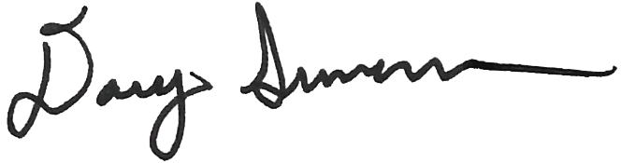 **Doug Swenson  
AGC Director of Safety & Field Training**

## Appendix A – Guidance for developing a COVID-19 Preparedness Plan

### General

[www.cdc.gov/coronavirus/2019-nCoV](http://www.cdc.gov/coronavirus/2019-nCoV)

[www.health.state.mn.us/diseases/coronavirus](https://www.health.state.mn.us/diseases/coronavirus/index.html)

[www.osha.gov](http://www.osha.gov)

[www.dli.mn.gov](http://www.dli.mn.gov)

### Handwashing

[www.cdc.gov/handwashing/when-how-handwashing.html](http://www.cdc.gov/handwashing/when-how-handwashing.html)

[www.cdc.gov/handwashing](https://www.cdc.gov/handwashing/index.html)

<https://youtu.be/d914EnpU4Fo>

### Respiratory etiquette: Cover your cough or sneeze

[www.cdc.gov/coronavirus/2019-ncov/prevent-getting-sick/prevention.html](http://www.cdc.gov/coronavirus/2019-ncov/prevent-getting-sick/prevention.html)

[www.health.state.mn.us/diseases/coronavirus/prevention.html](http://www.health.state.mn.us/diseases/coronavirus/prevention.html)

[www.cdc.gov/healthywater/hygiene/etiquette/coughing_sneezing.html](http://www.cdc.gov/healthywater/hygiene/etiquette/coughing_sneezing.html)

### Social distancing

[www.cdc.gov/coronavirus/2019-ncov/community/guidance-business-response.html](http://www.cdc.gov/coronavirus/2019-ncov/community/guidance-business-response.html)

[www.health.state.mn.us/diseases/coronavirus/businesses.html](http://www.health.state.mn.us/diseases/coronavirus/businesses.html)

### Housekeeping

[www.cdc.gov/coronavirus/2019-ncov/community/disinfecting-building-facility.html](http://www.cdc.gov/coronavirus/2019-ncov/community/disinfecting-building-facility.html)

[www.cdc.gov/coronavirus/2019-ncov/prevent-getting-sick/disinfecting-your-home.html](https://www.cdc.gov/coronavirus/2019-ncov/prevent-getting-sick/disinfecting-your-home.html)

[www.epa.gov/pesticide-registration/list-n-disinfectants-use-against-sars-cov-2](https://www.epa.gov/pesticide-registration/list-n-disinfectants-use-against-sars-cov-2)

[www.cdc.gov/coronavirus/2019-ncov/community/organizations/cleaning-disinfection.html](https://www.cdc.gov/coronavirus/2019-ncov/community/organizations/cleaning-disinfection.html)

### Employees exhibiting signs and symptoms of COVID-19

[www.cdc.gov/coronavirus/2019-ncov/if-you-are-sick/steps-when-sick.html](http://www.cdc.gov/coronavirus/2019-ncov/if-you-are-sick/steps-when-sick.html)

[www.health.state.mn.us/diseases/coronavirus/basics.html](http://www.health.state.mn.us/diseases/coronavirus/basics.html)

### Training

[www.health.state.mn.us/diseases/coronavirus/about.pdf](http://www.health.state.mn.us/diseases/coronavirus/about.pdf)

[www.cdc.gov/coronavirus/2019-ncov/community/guidance-small-business.html](https://www.cdc.gov/coronavirus/2019-ncov/community/guidance-small-business.html)

[www.osha.gov/Publications/OSHA3990.pdf](https://www.osha.gov/Publications/OSHA3990.pdf)